PLANNING DOCUMENT

For the ecoPineapple Project

*Team Values: Support each other | Free to speak | Push the boundaries | Skill development*

*Byron Chen - 92019472*

*Charles Tsao - 92019797*

*Trent Williams - 92019562*

# Table of Contents

sTable of Contents 1

1 User Stories 3

1.1 Website 3

1.2 Mobile Application 3

1.3 Mini Game 3

2 Meeting Minutes 1 4

2.1 29/08/19 - Client Meeting 1 4

3 Revised Design 6

3.1 Updated User Stories for Minigame 7

4 Sprint Planning 8

4.1 Sprint Tasks 8

4.1.1 SPRINT 1 8

4.1.2 SPRINT 2 9

4.1.3 SPRINT 3 9

4.1.4 SPRINT 4 10

4.1.5 SPRINT 5 10

4.2 Timeline 11

4.3 Scrum Master (SM) 11

5 Kanban Board 12

5.1 Links to Trello 12

5.2 Story Weights and Priority 12

5.3 Trello Screenshots 13

6 Development Tools 15

7 Meeting Minutes 2 16

7.1 11/09/19 - Client Meeting 2 16

8 Changes to Address Feedback 17

9 Execution - Iteration Planning 19

9.1 Sprint 1 19

9.1.1 Planned Deliverables 19

9.1.2 Demo – Client's Feedback 19

9.1.3 Screenshots of Actual Deliverables 20

9.2 Sprint 2 23

9.2.1 Planned Deliverables 23

9.2.2 Demo – Client's Feedback 23

9.2.3 Screenshots of Actual Deliverables 24

9.3 Sprint 3 29

9.3.1 Planned Deliverables 29

9.3.2 Demo – Client's Feedback 29

9.3.3 Screenshots of Actual Deliverables 30

9.4 Sprint 4 33

9.4.1 Planned Deliverables 33

9.4.2 Demo – Client's Feedback 33

9.4.3 Screenshots of Actual Deliverables 34

9.5 Sprint 5 37

9.5.1 Planned Deliverables 37

9.5.2 Demo – Client's Feedback 37

9.5.3 Screenshots of Actual Deliverables 38

10 Industry Engagement 41

10.1 Evidence 41

10.2 Feedback 45

# User Stories

The following user stories were created during our Project Kickstart Meeting. These reflect all the client’s initial requirements.

## Website

As a customer, I want to:

* View a Home Page
* View a Login Page
* View a Product List Page
* View a Product Details Page
* View a Staff Contracts Page
* Be able to add/edit products

As a staff member, I want to:

* Be able to login in and see contact information

## Mobile Application

As a customer, I want:

* To navigate to the pages via tabbed navigation
* Consistent styling for the page layouts that suit the topic
* A page that describes general sustainability issues
* A page that describes eco-friendly solutions
* A page showing space travel as an alternative to sustainability
* The application to be user accessible

## Mini Game

As a customer, I want to play:

* As a character
* Level 1 of the Game
* Level 2 of the Game
* Level 3 of the Game

# Meeting Minutes 1

The following are the meeting minutes recorded from the initial client meeting. This meeting involved the team clarifying and revising our design to match the client’s expectations.

## 29/08/19 - Client Meeting 1

**Meeting Scheduled for 11:00 am (30 minutes)**

**Actual time spent (11:00 – 11:30) am**

**Present – Byron, Charles, Trent, Clera**

Things we discussed in this meeting were:

* The creative control over the developed tools. Our team members will have most of the control, but the Client/Product Owner will need to approve these.
* The overall project schedule was discussed. It currently follows the default project schedule of 3 weeks for Project Proposal; 5 weeks for Project Execution; 2 weeks for Project Presentation.
* We requested if the name of the company can be changed from GreenWorld to ecoPineapple. This was approved by the Client.

**Trent Questions**

1. Should site be mobile friendly? Yes, it should be responsive.

2. How many photo’s per product? No set amounts. You can decide.

3. How long have you been about? 2 years

4. Why did you start? Bored of current job

5. Do you have different product categories? Yes. Categories such as kitchen, bathroom, food, fill your own (e.g. refill bottles).

6. Do you have any colour preference? No. Just keep the colours consistent.

7. Do you like the logo we propose and the name? Yes, I do.

8. For privacy, what details do you need to record about your staff? First name, last name, email, and phone. Department – log what they add etc.

9. What is your target market? Anyone interested in being eco-friendly. There is no age limit.

**Byron Questions**

1. What platforms do you want the game to run on? Preferably run on Windows 10. If implementation is straightforward, the Android platform is to be considered.

2. What should the target audience/age be for the game? Anyone who is a customer for ecoPineapple. Ages 3+.

3. What OFLC rating should the game strive for? G (General). This should be consistent throughout all created programs.

4. The unique selling points for this game is that coupon codes can be collected from the game to be used for the website. Is this okay? Yes.

5. You require at least 3 levels for the game. Is it okay to have these levels act as checkpoints for one single level? Yes, this is okay. But what if I wanted to play level 2?

**Charles’ Questions**

1. The application will focus on sustainability via the eco-friendly solutions that the store provides. A general definition of sustainability will also be provided. Is this content okay? Yes

2. The user groups for the mobile app are assigned as follows: Targeted – Customers of ecoPineapple; Supported – Visually impaired customers; and Non-Supported – Customers requiring localisation. Are these user groups defined correctly? Yes

3. I am suggesting adding a ‘hamburger’ button for flyout root navigation and a user accessibility page. Should I implement these features? Yes

# Revised Design

After the client meeting, the feedback provided was considered and addressed.

The following changes were applied to our overall design.

* The company name was changed from ‘GreenWorld’ to ‘ecoPineapple’.
* The number of planned Sprints is assigned to 5. For each sprint, the team members will spend an equal amount of time as Scrum Master.

For the mobile application, the following features were approved by the client.

* A product list of what the store offers is displayed.
* Product details for each product can be displayed.
* Social media integration will be available for products to be shared.
* Staff account access that allows staff to perform CRUD operations on announcements, products, and new staff users.

For the minigame, the following was clarified.

* Levels do not have to be a single individual scene, but levels can be a point that we reach in the game (e.g. Level 1 would be to fly to the moon and level 2 would be to fly to mars)

For the website, there were no additional changes that needed to be made.

## Updated User Stories for Minigame

After working through the GDD, new user stories were created for the minigame.

* Create character model (spaceship)
* Provide code for website products discount
* First prototype for the game
* Rocket launch and basic controls
* Money given based on how high the rocket reaches
* UI for purchasing and adding parts to the ship
* Basic models created
* Moon with spaceport added
* More planets added into space
* Tourists can go on the ship for money
* More controls for the ship to dock to space port
* Polish up UI
* More parts added to building the rocket
* Pickups and collectibles added
* Enemies added (alien ships and asteroids)
* Music and sound added
* Final models added
* Loading screen menu
* Save system

*Note: This section is included here in the Planning document as it does not belong in the Game Overview or GDD documents.*

# Sprint Planning

## Sprint Tasks

The following is an initial plan of the tasks that will be included in each of the sprints.

### SPRINT 1

**Mobile application**

Set up the development environment and rapidly prototype a skeleton for the mobile application. This will involve setting up the development environment; set up the base project; implementing simple UI layout; set up tabbed navigation; set up flyout shelf; set up staff access and functionality; etc.

**Mini-Game**

First I will create a prototype version of the game. This will include a basic rocket launch with basic controls, a moon with a star port attached to it, money system, and a simple UI for adding parts to the rocket. The models for all the designs will be basic shapes.

**Website**

1. Base structure pages created
2. Base data structure created
3. Some basic navigation functionality
4. Some static content

### SPRINT 2

**Mobile application**

Tasks will building upon the skeleton prototype and finish off any features that has not been implemented. Will also start creating content for the application and making sure it is implemented properly and is responsive. Content will involve text bodies of sustainability information, announcements, products, and staff users.

**Mini-Game**

The game will have more planets added to the map for the player to fly to. Tourists system will be added in. More controls will be added for the rocket to dock to a space port.

**Website**

1. Static content finished
2. All primary user stories working on desktop version
3. Mobile responsiveness development started

### SPRINT 3

**Mobile application**

Tasks will involve implementing any major changes provided by the client; continue with creating responsive content; and polishing the UI with consistent styling/colours.

**Mini-Game**

Polishing up the UI. More parts will be added into the rocket ship design phase. Parts that you can collect will be added for during launch phase. Polished models will be added to all the game objects.

**Website**

1. Mobile responsiveness development finished
2. User access
3. User access – customizing content

### SPRINT 4

**Mobile application**

Implement any leftover high/mid priority features.

**Mini-Game**

Enemies and asteroids will be added into game which the player needs to avoid. More polishing will be done to the design.

**Website**

* TBC as changes are considered and new user stories to be implemented, that we assume will come during the first 3 sprints.

### SPRINT 5

**Mobile application**

Finalising application before presentation.

**Mini-Game**

An android version of the game will be created. UI and screen size will be adjusted to fit the game in.

**Website**

* TBC as changes are considered and new user stories to be implemented, that we assume will come during sprints 1-4.

## Timeline

This is the current planned timeline for our project. Each sprint is expected to last one week.

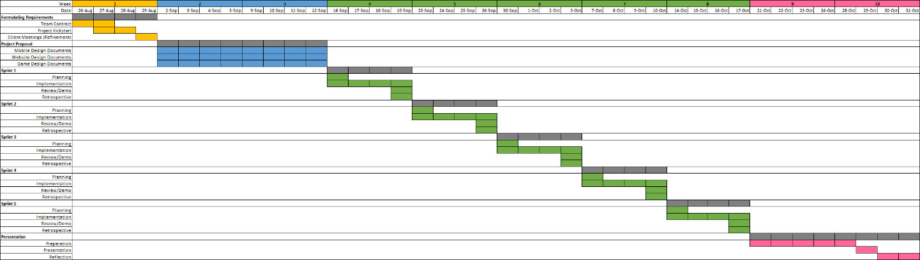

## Scrum Master (SM)

For our planned sprints, the role of Scrum Master will be assigned as follows:

* Sprint 1 – Charles and Trent
* Sprint 2 – Charles and Byron
* Sprint 3 – Trent
* Sprint 4 – Byron
* Sprint 5 – Charles

The reasoning for assigning two team members to share the Scrum Master role during the initial sprints is to help the team become familiar with the SM duties and provides a chance for us to optimise the SM tasks for future sprints. It also allows each team member to contribute as the Scrum Master at least twice during the project execution.

Some of the main SM duties will involve:

* Organising Scrum ceremonies for the team and Product Owner.
* Managing the Product Backlog
* Implement changes to increase team productivity
* Removing obstacles that hinders the team’s effectiveness

# Kanban Board

## Links to Trello

Project Link: <https://trello.com/ecopineapple/home>

Invite Link: <https://trello.com/invite/ecopineapple/1ce8f55ca9f9ae0a7a93bb6ba1ca4e15>

## Story Weights and Priority

Planning Poker was played using our mobile devices to assign a weight for all the user stories created. This was done once the design had been complete and before the final client meeting to confirm everything planned.

Each point is weighted as 1 hour and the amount of hours we will spend each week during project execution will be 20 hours per member. This will result in a planned sprint velocity of around 20 points for each app.

Also, we assigned each user story with one of the following priorities:

* 1 = High Priority (Red)
* 2 = Medium Priority (Orange)
* 3 = Low Priority (Green)
* 4 = On hold (Blue)

## Trello Screenshots

The following figures are a snapshot of the Kanban boards on Trello after all design and implementation tasks have been applied. The sprint tasks will be moved to the ‘In Progress’ column during the sprint planning meeting.

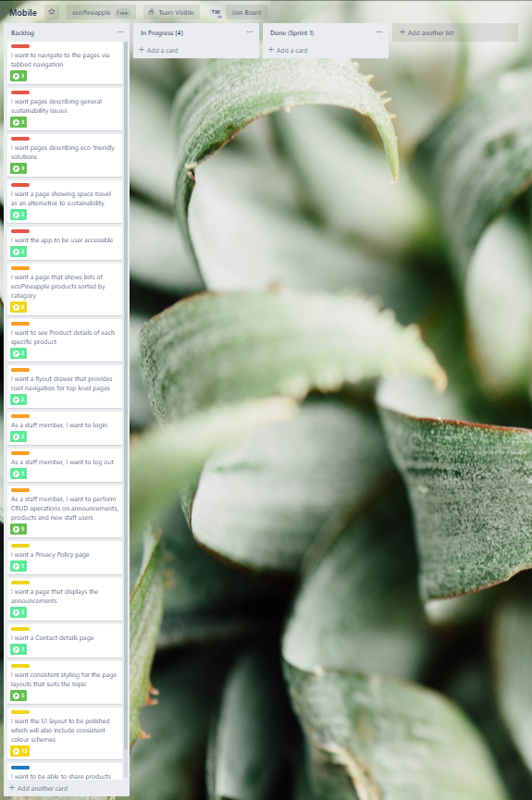

**Mobile Application Board**

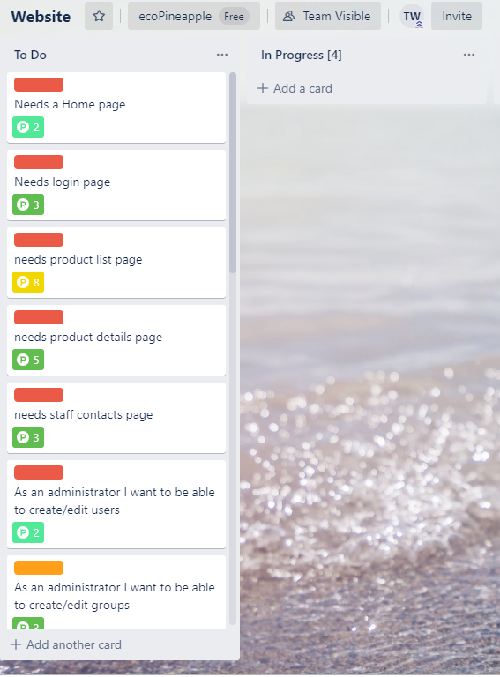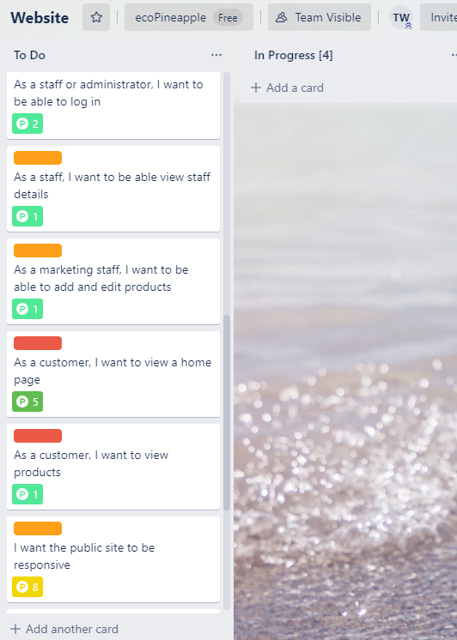

**Website Board**

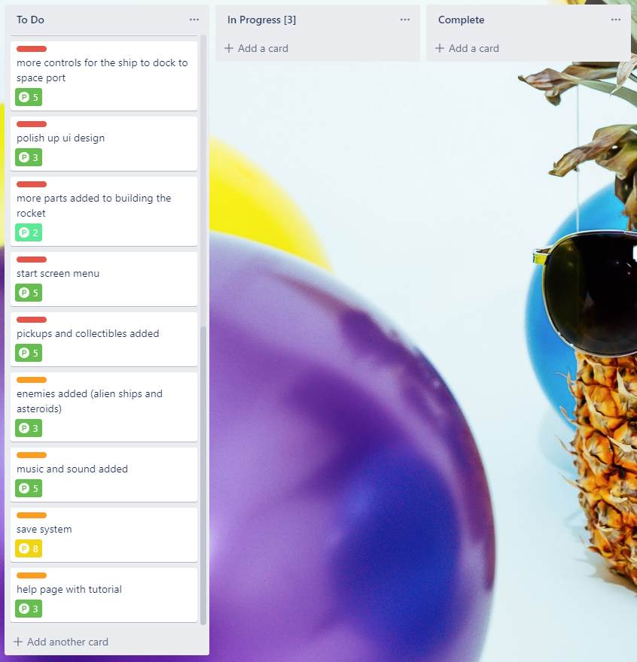

**Minigame Board**

# Development Tools

As a team, we agreed to use the following development tools to create our applications. These tools were selected as we have used them in previous projects.

|  |  |
| --- | --- |
| **Purpose** | **Development Tools** |
| Game Development | Visual Studio 2019, Unity 2019.1b |
| Mobile Development | Visual Studio 2019, Xamarin.Forms, Xamarin.Android, Android Studio, Mobile Development tools for Visual Studio |
| Website Development | Django, Node.Js, Visual Studio 2019, React.Js |
| Databases | SQLite3, MySQL |
| Planning | Trello |

# Meeting Minutes 2

The following are the meeting minutes that were recorded after presenting all the proposal documentation to the client. This meeting involved the team presenting a short overview of the proposal and provided another opportunity for the client to provide feedback for the team to address.

## 11/09/19 - Client Meeting 2

**Meeting Scheduled for 9:00 am (30 minutes)**

**Actual time spent (9:15 – 9:45) am ***Byron a bit late\*\*\***

**Present – Byron, Charles, Trent, Rob**

Things we discussed in this meeting were:

* Presented an overview of our applications.
* The schedule of weekly meetings involving sprint demos/retrospective
* Changes for the game – The discount codes offered for playing the game should be accessible to even users who are not great at playing games.
* Changes for the mobile app – No changes. Just make sure the content is meaningful.
* Changes for the website – The design will need to include functionality for how the warehouse team of ecoPineapple receives cart orders.

# Changes to Address Feedback

These changes were made to the design documents following Client Meeting 2. These are also documented in the IT6041_DevelopmentLog.

**IT6041_GDD**

Changes made on 16/09/2019 (following the client meeting)

* **Page 12**

An initial milestone will be provided that is easy to achieve. This is to help make discount codes more accessible to the general audience, who not all may be great at playing games. **– ADDED**

Added so that the discount codes offered for playing the game should be accessible to all users, even ones who are not great at playing games

**IT6041_WDD**

Changes made on 16/09/2019 (following the client meeting)

* **Page 3**

***In User Stories***

As warehouse staff, I want to see orders that need packing – **ADDED**

***In Stakeholder List***

Clients – Management, Marketing, Warehousing & IT Team - **UPDATED**

***In Identified user roles***

Warehouse Staff - who will process orders placed – **ADDED**

Note: Warehouse staff will be excluded from the development on this project, however included up until this point as they are part of the supply chain to get a product delivered to the customer. – **ADDED**

* **Page 4**

***In Context Diagram***

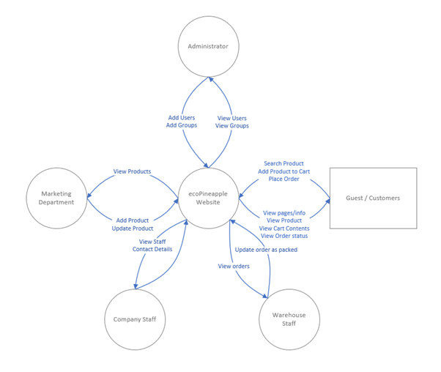

* **UPDATED**
* **Page 5**

***In User Functional Diagram***

Note: Warehouse staff have been excluded at this point as they are not being designed or catered for in the initial release. – **ADDED**

These changes were made to include functionality for how the warehouse team of ecoPineapple receives cart orders.

# Execution - Iteration Planning

## Sprint 1

### Planned Deliverables

**Mobile application**

Set up the development environment and rapidly prototype a skeleton for the mobile application. This will involve setting up the development environment; set up the base project; implementing simple UI layout; set up tabbed navigation; set up flyout shelf; set up staff access and functionality; etc.

**Mini-Game**

First I will create a prototype version of the game. This will include a basic rocket launch with basic controls, a moon with a starport attached to it, money system, and a simple UI for adding parts to the rocket. The models for all the designs will be basic shapes.

**Website**

1. Base structure pages created
2. Base data structure created
3. Some basic navigation functionality
4. Some static content

### Demo – Client's Feedback

**23/09/19 - Sprint 1 – Sprint Demo**

**Scrum Master – Charles**

**Meeting Scheduled for 10:00am (30 minutes)**

**Actual time spent (10:00-10:15) am**

**Present – Byron, Charles, Trent, Rob**

First, we addressed Rob with what we were delivering during this demo against our initial sprint plan. Our actual deliverables were surprising close to our planned sprint deliverables, except for a couple of features. For the website, we did not set up a basic data structure; and for the mobile application, we did not set up staff access/functionality. These tasks will be assigned for the next sprint.

After demonstrating the applications, Rob gave us the following feedback:

**Website**

* Keep the design focus for the user experience
* Provided a suggestion to stretch the banner to fit the whole screen
* Otherwise, things are developing well.

**Mobile**

* Page navigation is looking great
* If the information on the pages need updating, how will it be handled?
* Having the correct fonts is not a big issue. The three Android system fonts will suffice for now.

**Minigame**

* Game is looking great. Can the graphics be more polished?
* Are you able to set the background to space? And will only one background be used throughout the minigame?
* Will this be available to be ported to Android? Are you designing it with mobile accessibility in mind?

After addressing Rob’s feedback, we provided him with our planned sprint deliverables for next sprint. These deliverables will include the missing features that were previously mentioned, and all the tasks that we have planned out for Sprint 2 in the IT6041_Planning document.

Overall, the applications we demonstrated during this meeting were still quite bare in terms of features and content. This was expected as this was our first Sprint Demo.

### Screenshots of Actual Deliverables

**Minigame**

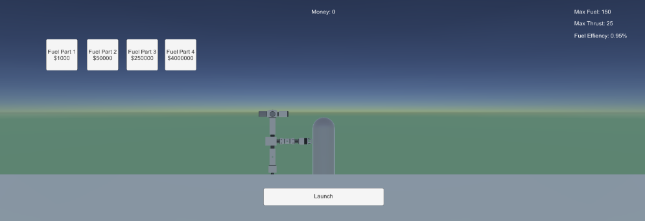

*Build phase menu*

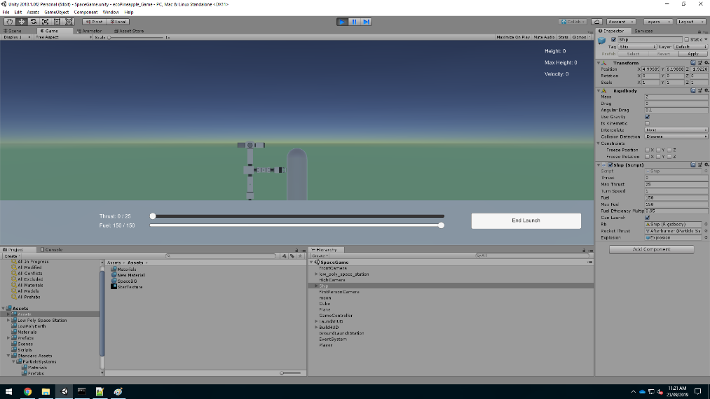

*Pre-Launch Rocket Flight*

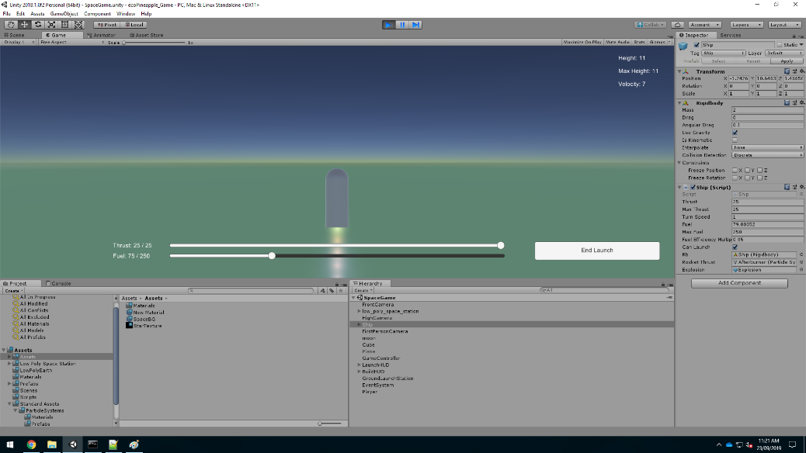

*In-Launch Rocket Flight*

**Website**

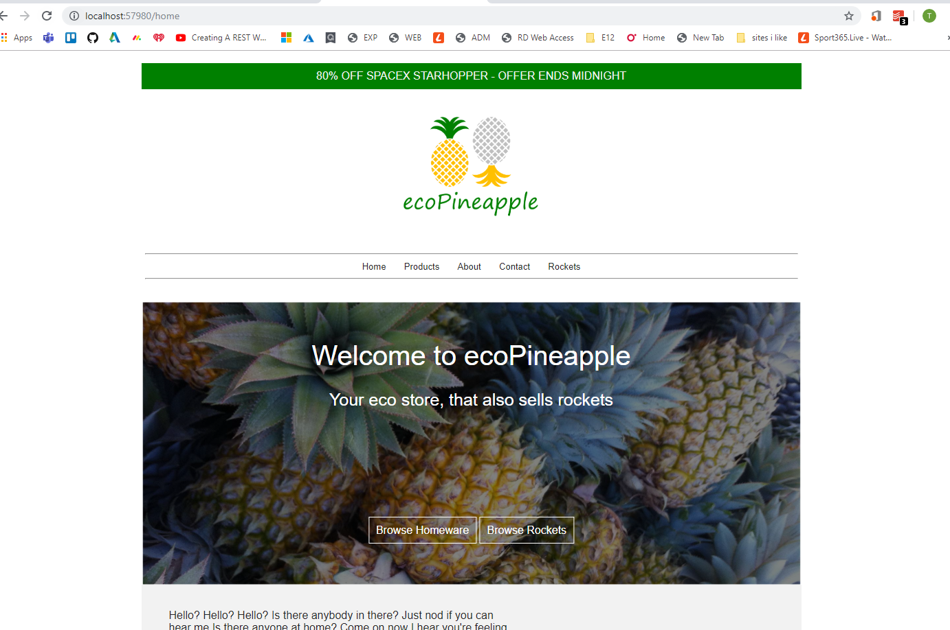

*Home Page*

**Mobile Application**

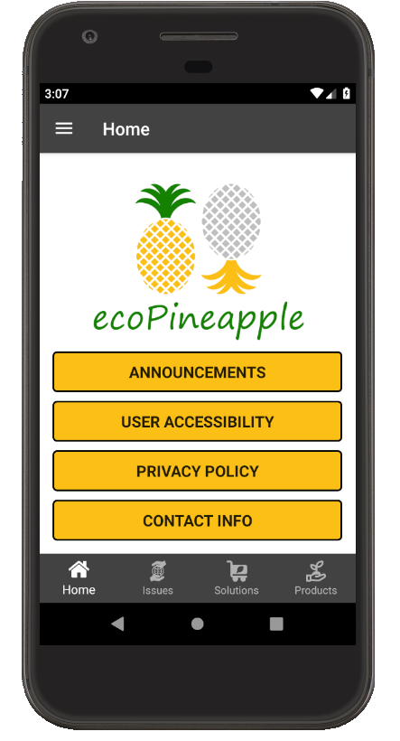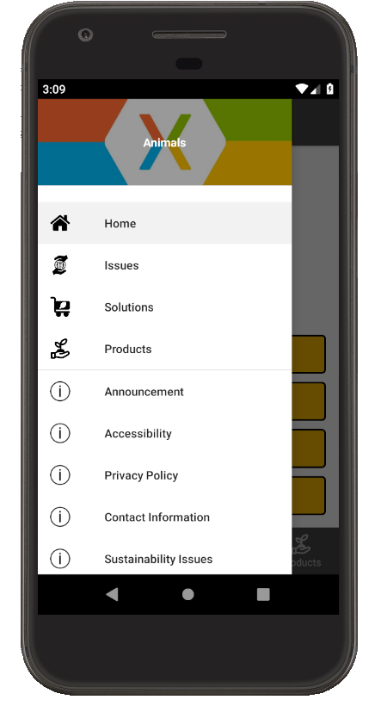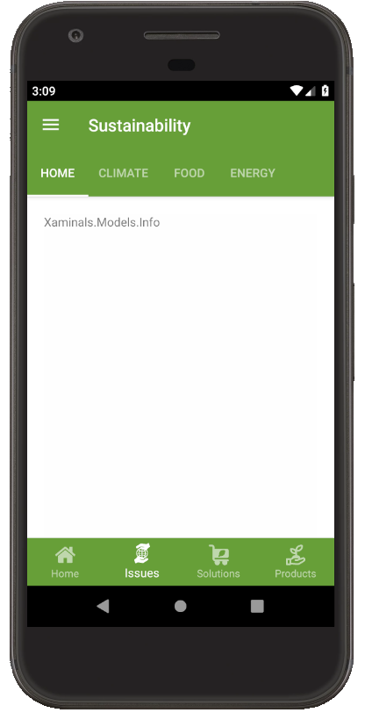

*From left to right:*

*Home Page, Flyout Drawer, Test Page for Sustainability Home Topic*

## Sprint 2

### Planned Deliverables

**Mobile application**

Tasks will building upon the skeleton prototype and finish off any features that has not been implemented. Will also start creating content for the application and making sure it is implemented properly and is responsive. Content will involve text bodies of sustainability information, announcements, products, and staff users.

**Mini-Game**

The game will have more planets added to the map for the player to fly to. Tourists system will be added in. More controls will be added for the rocket to dock to a space port.

**Website**

1. Static content finished
2. All primary user stories working on desktop version
3. Mobile responsiveness development started

### Demo – Client's Feedback

**30/09/19 - Sprint 2 – Sprint Demo**

**Scrum Master – Charles**

**Meeting Scheduled for 10:30am (15 minutes)**

**Actual time spent (10:40-10:55) am**

**Present – Byron, Charles, Trent, Rob**

This demonstration went smoothly as planned. Again, we presented Rob with our sprint deliverables and compared it to our plan from the start of the sprint. The sprint mostly focused on adding content for the product/content views of our applications. There were also the authentication features being started and the game mechanics being further developed. The only planned features that were not implemented were: for the mobile application, the product models/pages and the staff user access; and for the website, designing for mobile responsiveness. As normal, these tasks will be assigned to the following sprint.

After demonstrating the applications, Rob gave us the following feedback:

**Website**

* The functionality to add a product, user or group looks great.
* For the product details, can we add a long description to the product?

**Mobile**

* The content and how it is styled looks great.
* Can I get a themed navigation bar to promote our brand? Maybe a 50% opacity pineapple image layered over the navigation bar.

**Minigame**

* There is a lot of numbers used to display money (i.e. lots of zeroes). Can we make our own currency to reduce the amount of numbers displayed?

During the demonstration of the minigame, we suggested to Rob our plan to change the game world so that it was rendered in 2D instead of 3D. This was due to 2D game content being easier to create and the fact that our Unity version 2018.1.0f2 does not support the latest free assets from the Unity asset store. Rob approved our suggestion, and these design changes will be documented by updating the GDD.

We then provided Rob with our planned sprint deliverables for next sprint. These will include the unfinished features from the previous sprint, the changes that Rob provided and all the tasks that we have planned out for Sprint 3 in the IT6041_Planning document.

However, the deliverables for the mobile application are reduced for next sprint. This is because we need to get industry feedback for the game. A large game meetup is happening 3 days from now, so we need more time spend more time developing the game.

### Screenshots of Actual Deliverables

**Minigame**

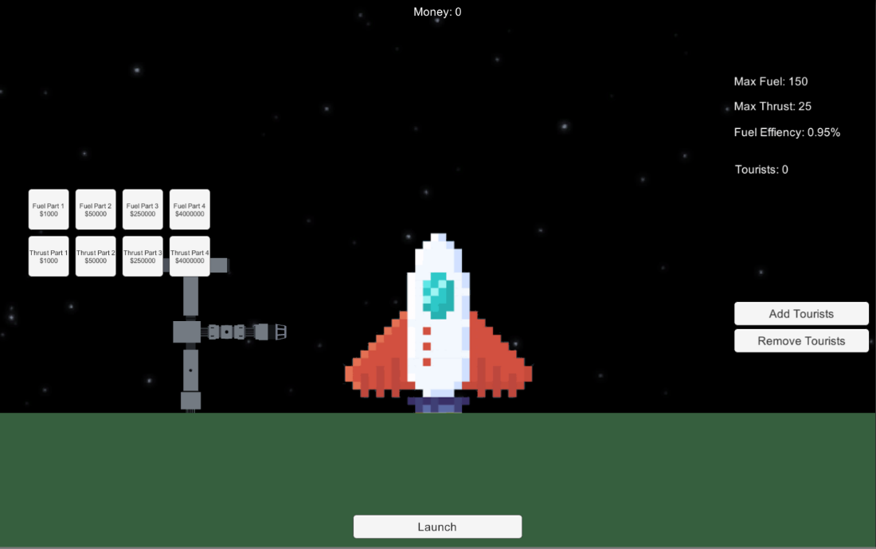

*Changed UI for Build Phase*

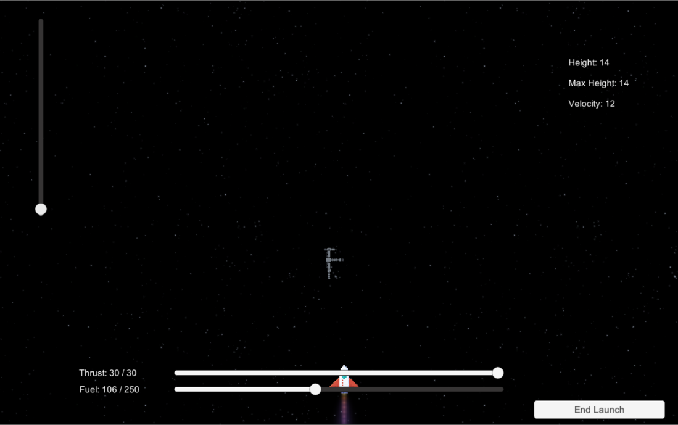

*Changed UI for Launch Phase*

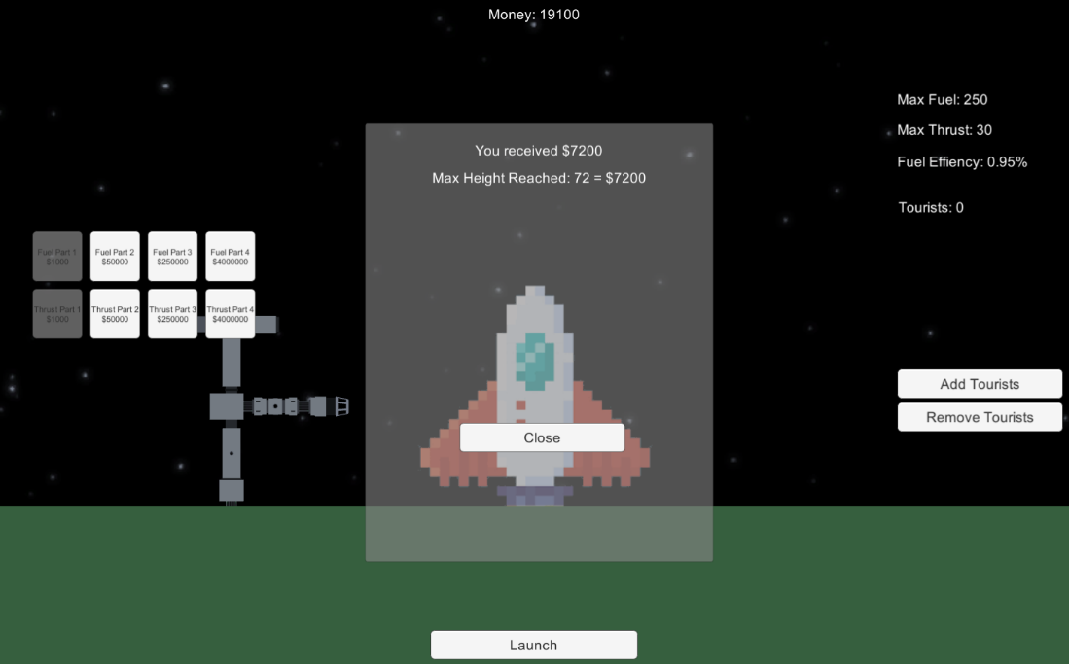

*Score Display Screen*

**Website**

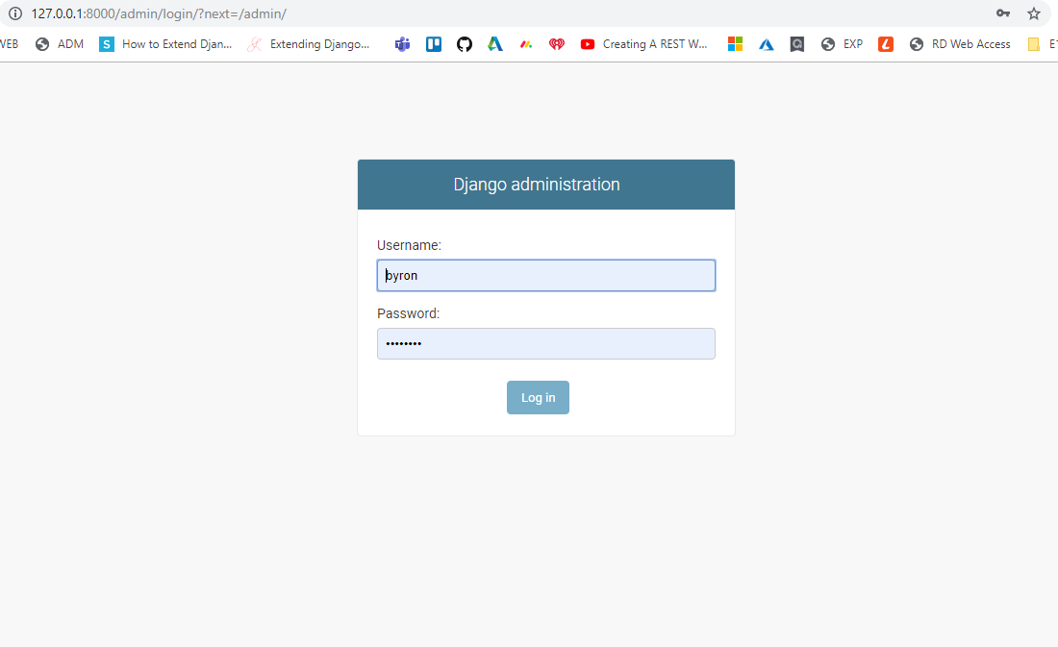

*Administration*

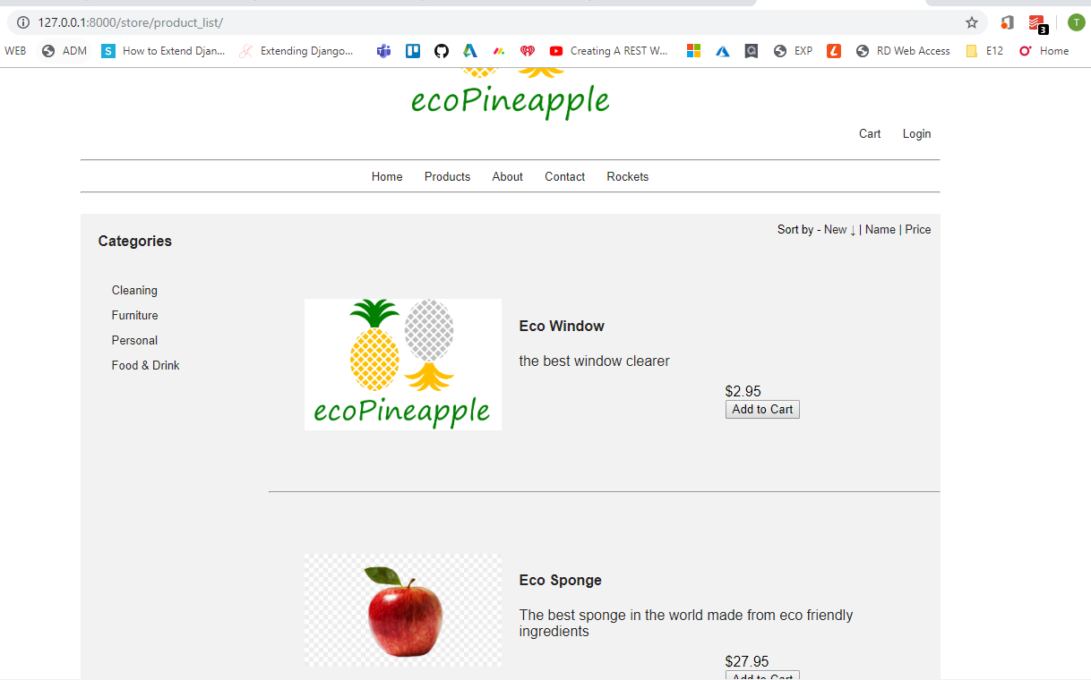

*Product List*

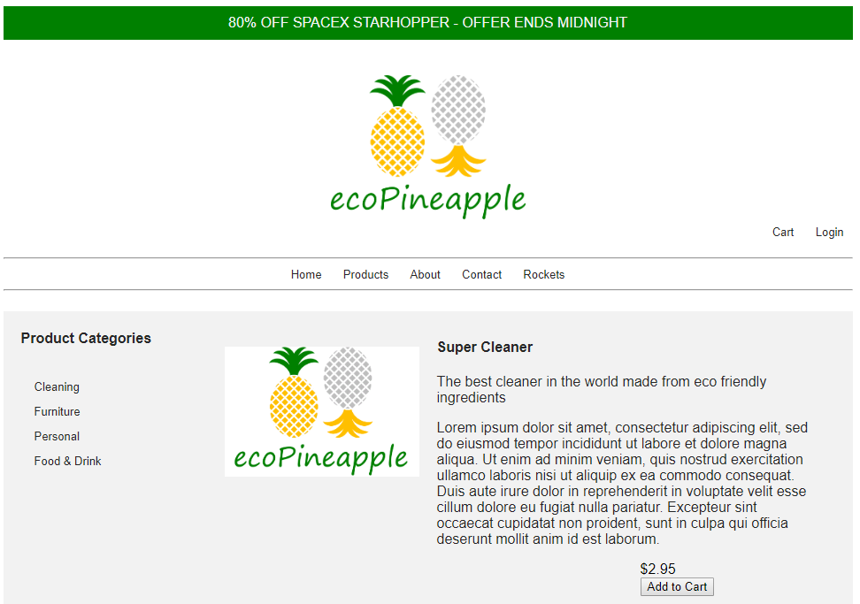

*Product Details*

**Mobile Application**

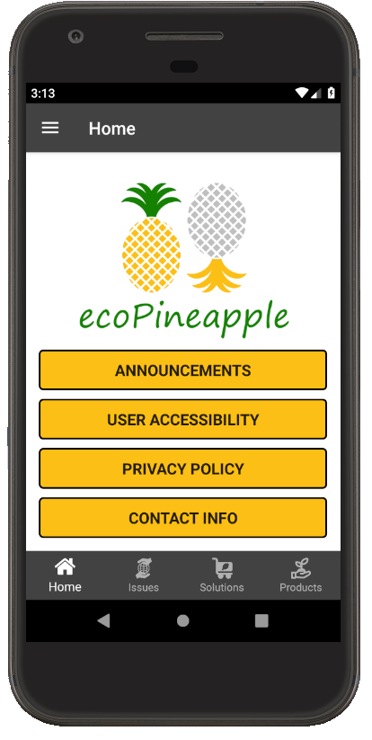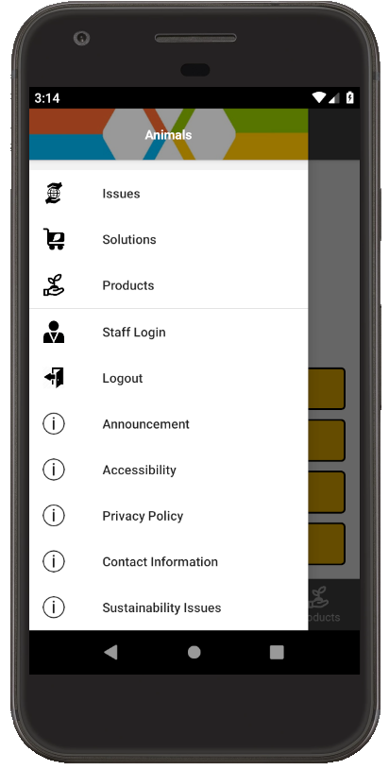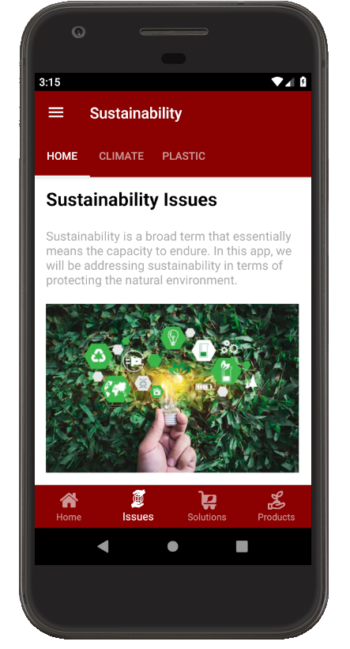

*From left to right:*

*Home Page, Flyout Drawer, Sustainability Topic Home Page*

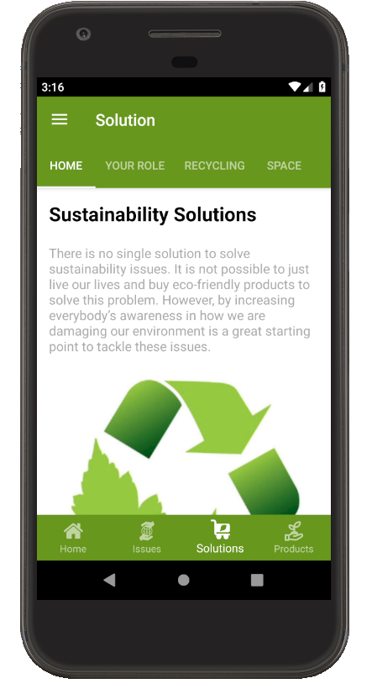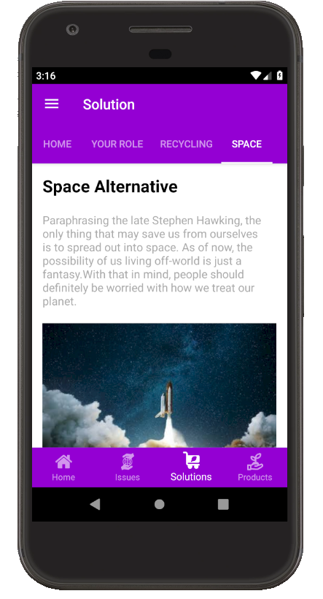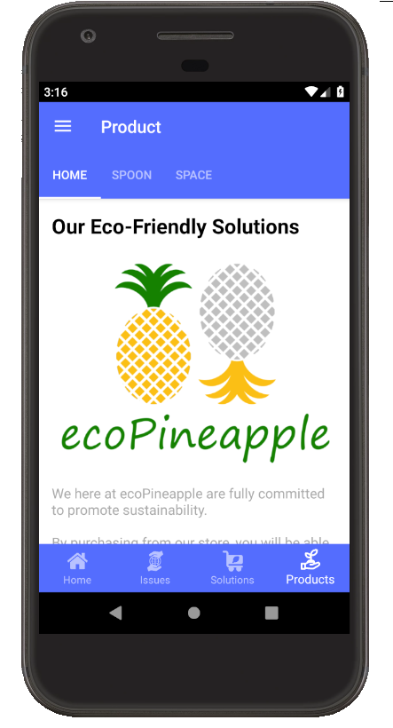

*From left to right:*

*Solution Topic Home Page, Space Solution Page, Product Home Page*

## Sprint 3

### Planned Deliverables

**Mobile application**

Tasks will involve implementing any major changes provided by the client; continue with creating responsive content; and polishing the UI with consistent styling/colours.

**Mini-Game**

Polishing up the UI. More parts will be added into the rocket ship design phase. Parts that you can collect will be added for during launch phase. Polished models will be added to all the game objects.

**Website**

1. Mobile responsiveness development finished
2. User access
3. User access – customizing content

### Demo – Client's Feedback

**07/10/19 - Sprint 3 – Sprint Demo**

**Scrum Master – Trent**

**Meeting Scheduled for 10:00am (15 minutes)**

**Actual time spent (10:00-10:15) am**

**Present – Byron, Charles, Trent, & Clera**

Firstly, due to the Product Owner role returning to Clera, we advised her on where we were at.

We also told her we had been to a Christchurch Game Developers meetup last week to get industry feedback. We told her that we demonstrated the game to Len Stalker, who is a Mobile Developer at Verizon Connect. We communicated the useful feedback provided by Len to Clera.

After demonstrating the applications, Clera gave us the following feedback:

**Game**

* Clera asked about the levels and the code; making sure that we fulfill the original project criteria. We explained the game’s milestones, levels, score etc.
* She also requested if the game will have sound effects and music. We added this to our backlog and would implement this eventually.
* She asked if the game could be made into a multiplayer game. We denied this request due to the huge scope of that task.
* Overall, she liked the game.

**Website**

* Overall, she liked the site and discussed who could add the products.
* We spoke about adding the discount code and how this can be implemented. This involved whether the reduced price after adding the code is shown at the cart checkout or on the product details page. This is currently outside our scope for the project and will be added to the product backlog as an item to come. It will most likely not be developed as part of this project.
* Lastly, she spoke about the cart and how we add/delete/modify the cart contents. This is outside the scope of the project and will be added to the product backlog as an item to come but will not be developed as part of this project.

**Mobile App**

* As the mobile application barely changed since the last sprint, Clera did not have any additional feedback.
* Overall, she liked the app and ask to continue implementing the backlog tasks.

### Screenshots of Actual Deliverables

**Minigame**

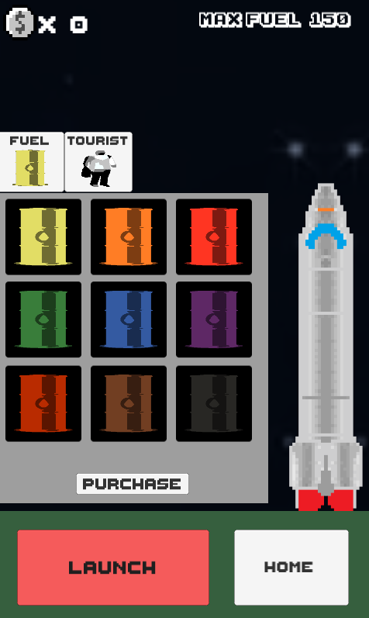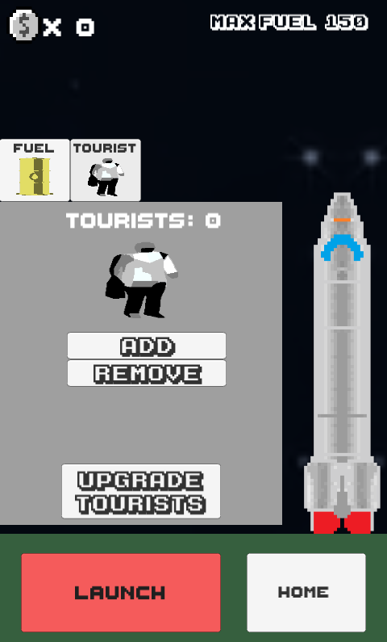

*Build Screen Overhaul - Can now add tourists*

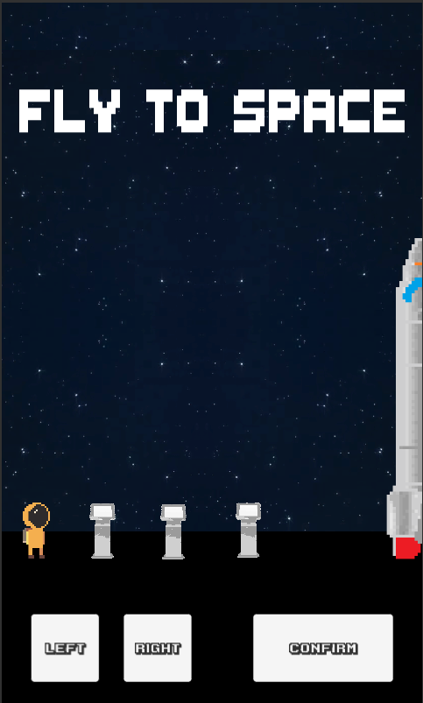

*Start screen with some functionality to move*

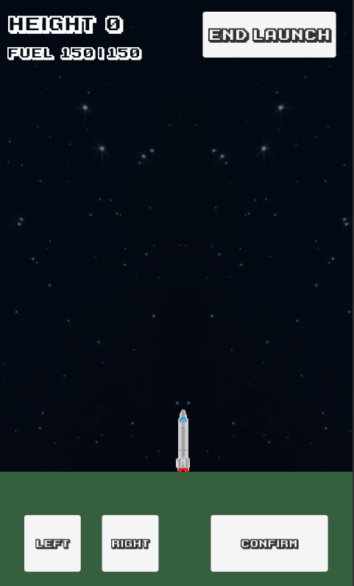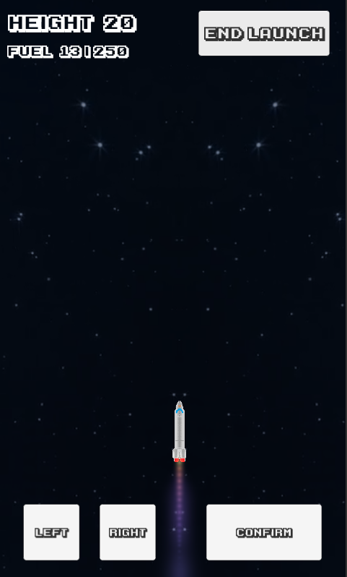

*Launch Phase with left and right buttons for Android*

**Website**

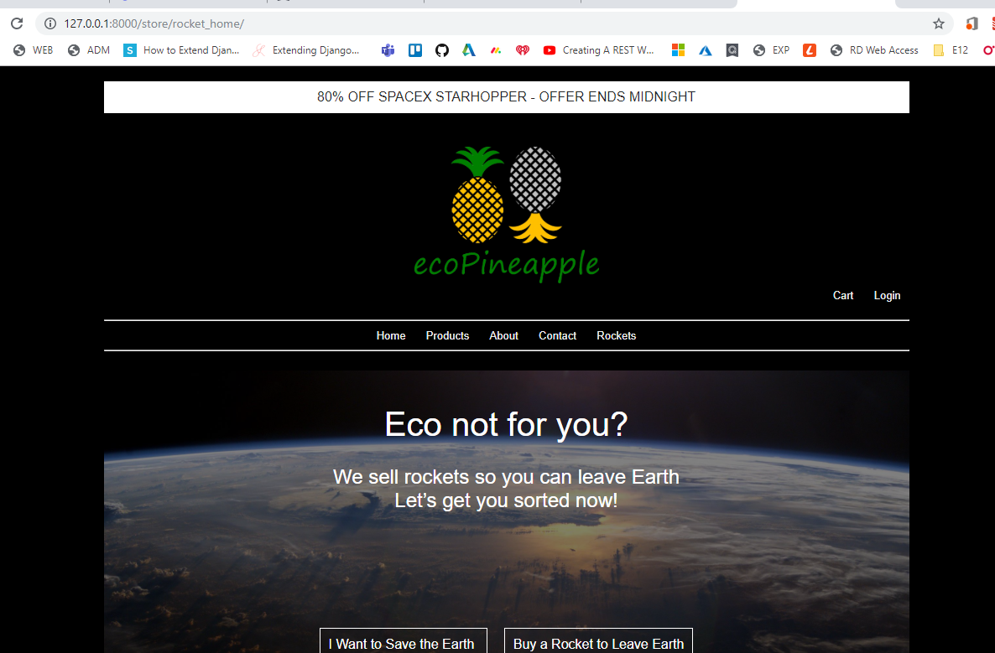

*Rocket Home Page*

**Mobile Application**

The application demonstrated at the end of Sprint 3 had no major changes since the previous sprint. However, all the features were demonstrated since our original client returned.

## Sprint 4

### Planned Deliverables

**Mobile application**

Implement any leftover high/mid priority features.

**Mini-Game**

Enemies and asteroids will be added into game which the player needs to avoid. More polishing will be done to the design.

**Website**

* TBC as changes are considered and new user stories to be implemented, that we assume will come during the first 3 sprints.

### Demo – Client's Feedback

**14/10/19 - Sprint 4 – Sprint Demo / (Final meeting with client prior to the Project Presentation)**

**Scrum Master – Byron**

**Meeting Scheduled for 10:30am (15 minutes)**

**Actual time spent (10:30-10:45) am**

**Present – Byron, Charles, Trent, Clera**

The demo went well with the client. She was satisfied with the applications that we presented, and it matches her initial expectations. The client liked what we had because when compared to the previous sprint, we did not implement many different features and instead focused on polishing our applications.

The client provided us with some feedback and improvements for each of the applications.

**Game**

* Client liked the game and how it plays. Not too much feedback on the rest.
* Client said that she would like to have music and sound effects for the game.
* Client would like to have a text to speech functionality for the dialog.

**Website**

* Client would like to have sorting features implemented for the products. Features such as sort by name, sort by price, etc.

**Mobile**

* Client would like to reformat and polish the home page.

### Screenshots of Actual Deliverables

**Minigame**

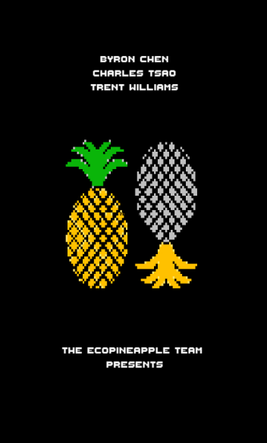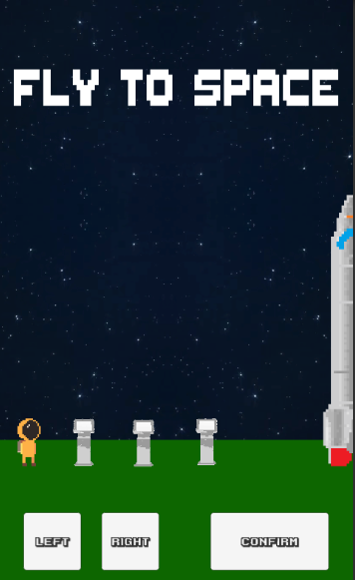

*Splash Screen / Start Screen*

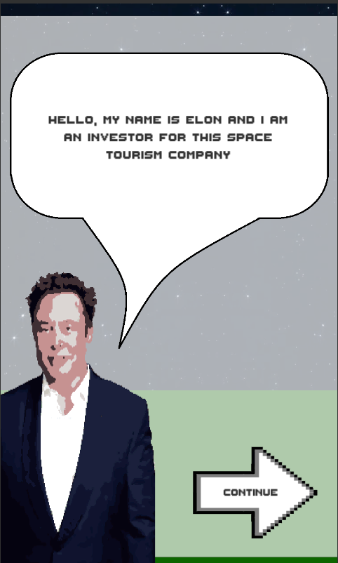

*Story Screen*

**Website**

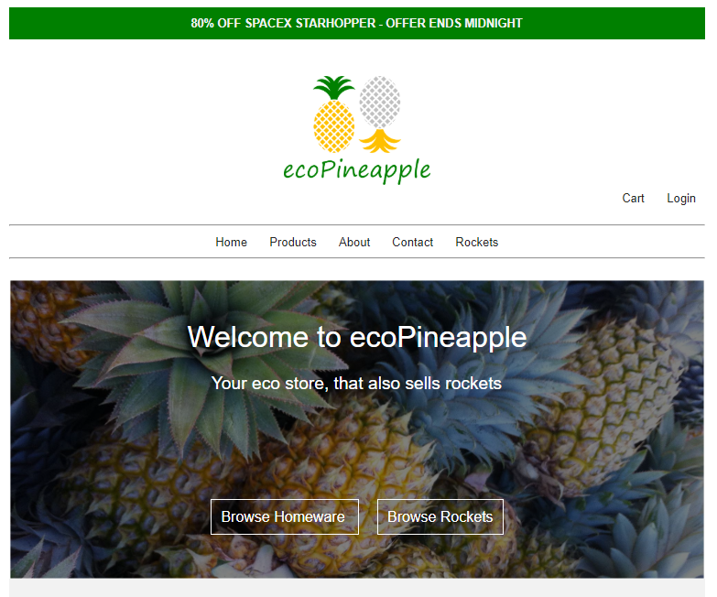

*Mobile Responsiveness – Tablet*

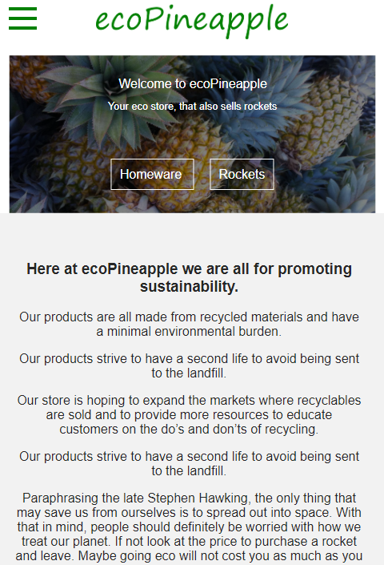

*Mobile Responsiveness – Mobil*e

**Mobile Application**

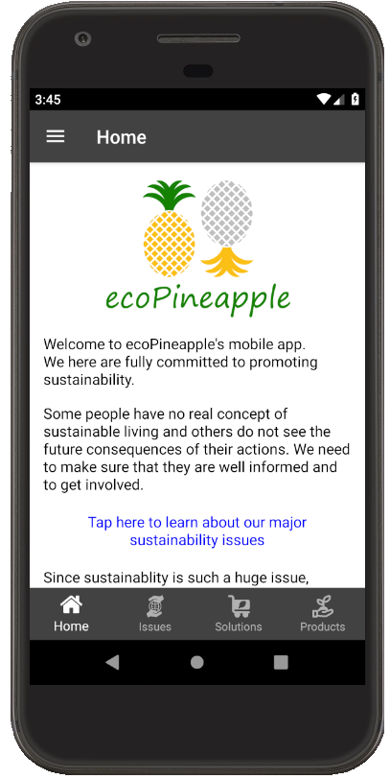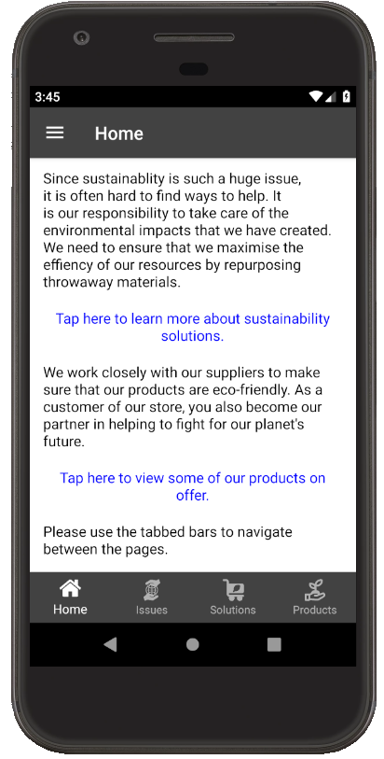

*From left to right:*

*Home Page, Home Page (scrolled down)*

## Sprint 5

### Planned Deliverables

**Mobile application**

Finalising application before presentation.

**Mini-Game**

An android version of the game will be created. UI and screen size will be adjusted to fit the game in.

**Website**

* TBC as changes are considered and new user stories to be implemented, that we assume will come during sprints 1-4.

### Demo – Client's Feedback

**17/10/19 - Sprint 5 – “Sprint Demo”**

**Scrum Master – Charles**

**Meeting Scheduled for 10:15am (15 minutes)**

**Actual time spent (10:15-10:25) am**

**Present – Byron, Charles, Trent, Clera**

This demo was used to comply with having a sprint demo at the end of each week. Except for the game, not much else has changed with our applications. We demonstrated the different story scenes that set up each level for the game and the music/sfx. Clera was satisfied with the implementation of her request for sounds.

We also showed Clera the sort controls on the website, we were able to show where these would go, however due to time constraints, and how the results were returned, we were not 100% on the best way to implement these at this time, they would be addressed next, if the project continued.

She also talked about some administrative tasks relating to the project. Of note is that all documentation and code is to be submitted by Monday evening (21st October).

### Screenshots of Actual Deliverables

**Minigame**

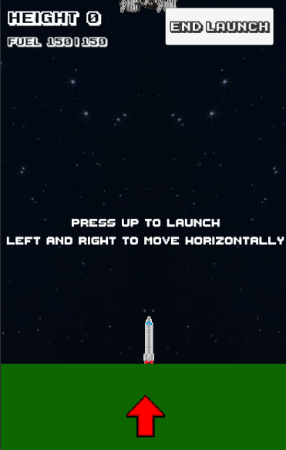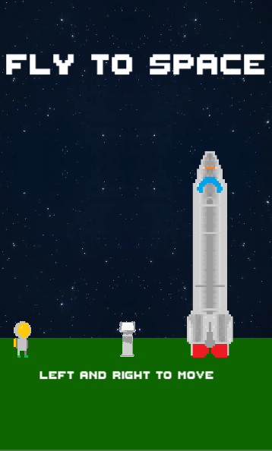

*Additional help dialog added to scenes*

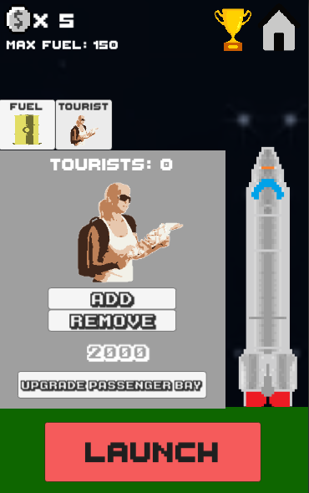

*Tourists limit added to game*

**Website**

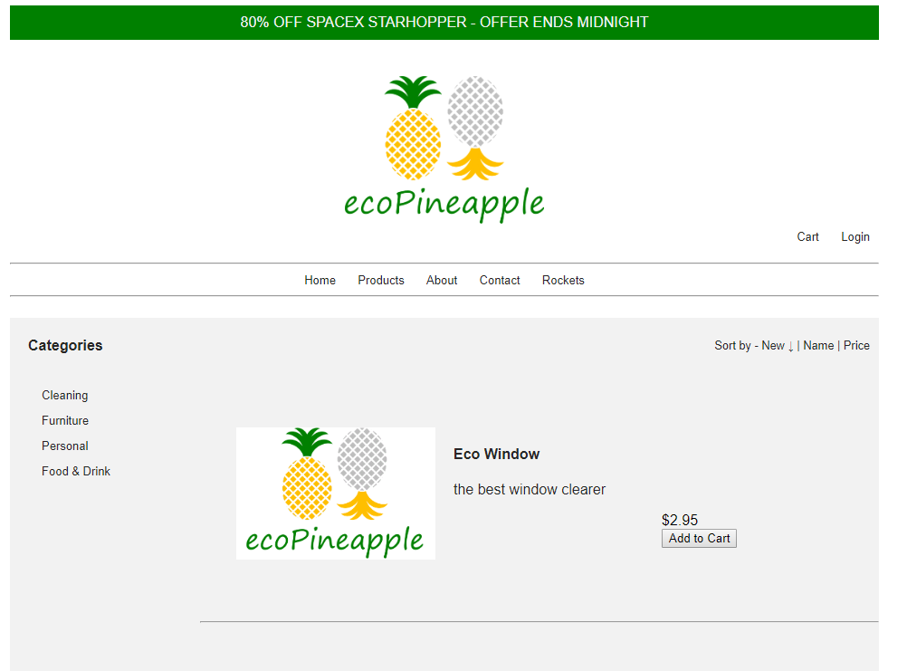

*Sort controls added to product list*

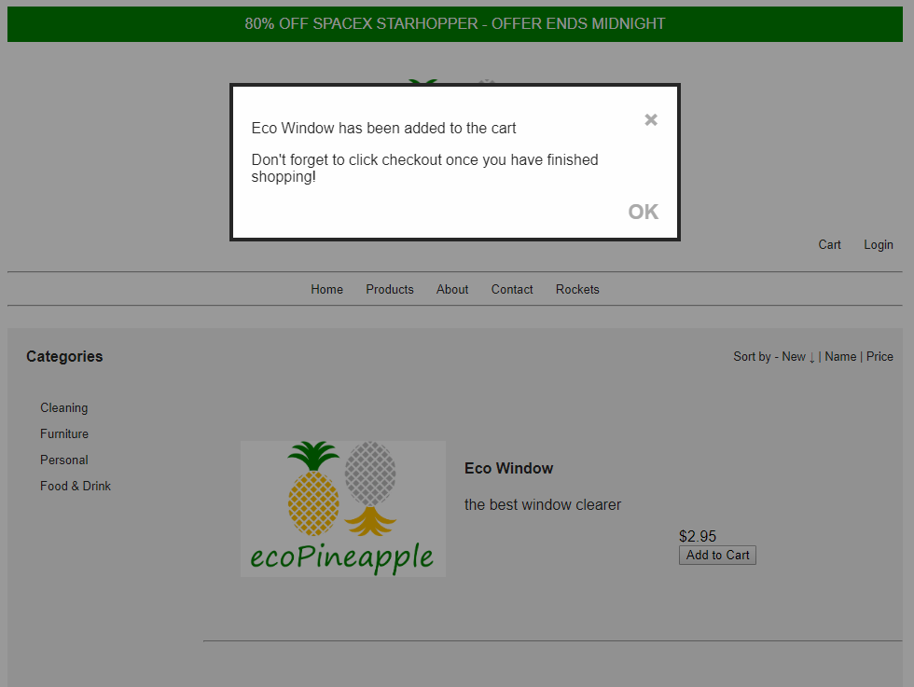

*Confirmation when adding item to cart*

**Mobile Application**

Screenshots show the Home Page and Flyout drawer that is using Android’s largest font size setting. The app was built and deployed on a virtually emulated Nexus 4 running Android 7.0 (API 24).

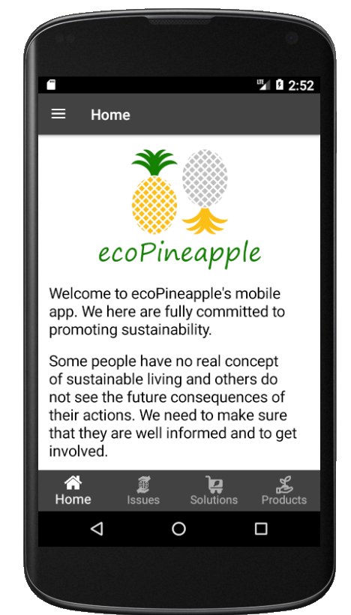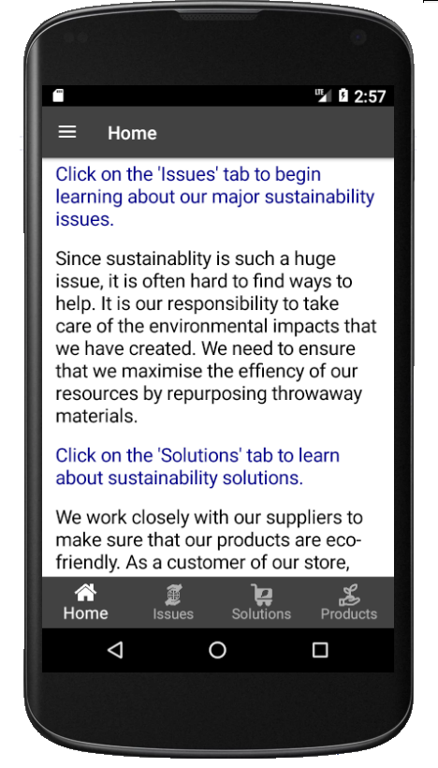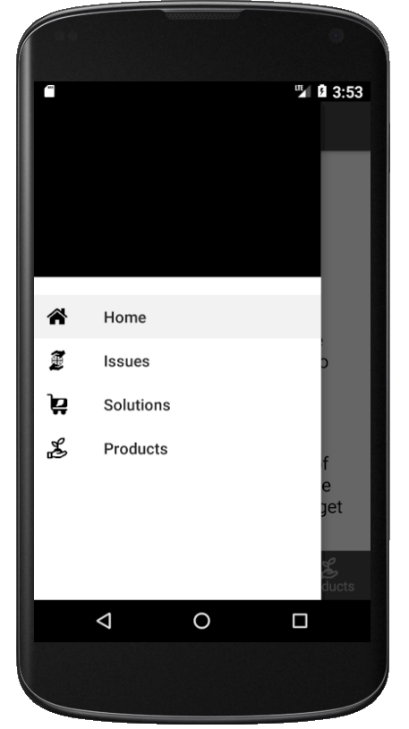

*From left to right:*

*Home Page, Home Page (scrolled down), Flyout Drawer*

# Industry Engagement

## Evidence

Our team attended the October Game Developers Meetup on Thursday 3rd October 2019 at 6:30pm.

The link to the event can be found here: <https://www.meetup.com/ChristchurchGameDevelopers/events/264982108/>

Below are photos from the event.

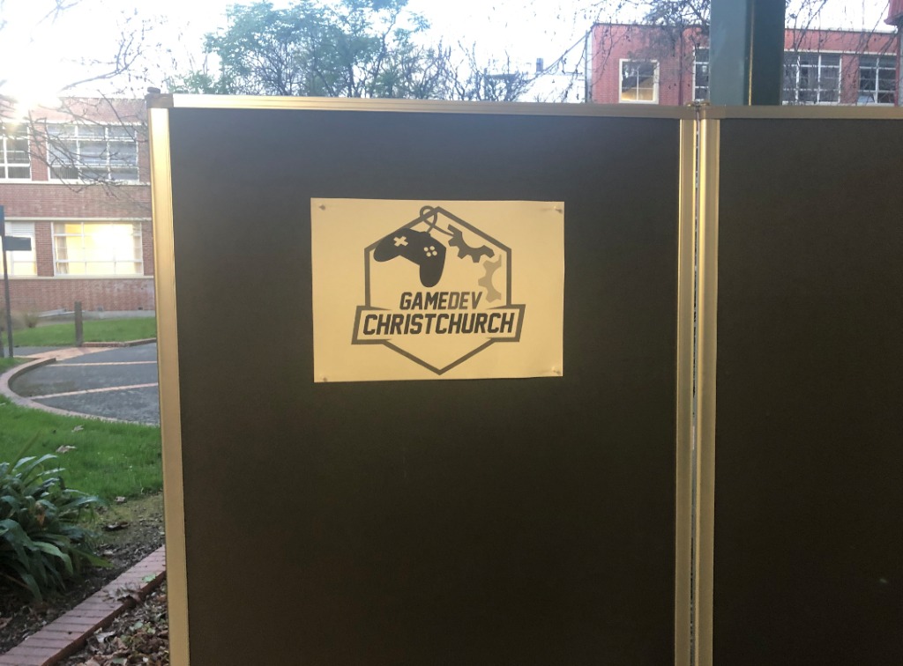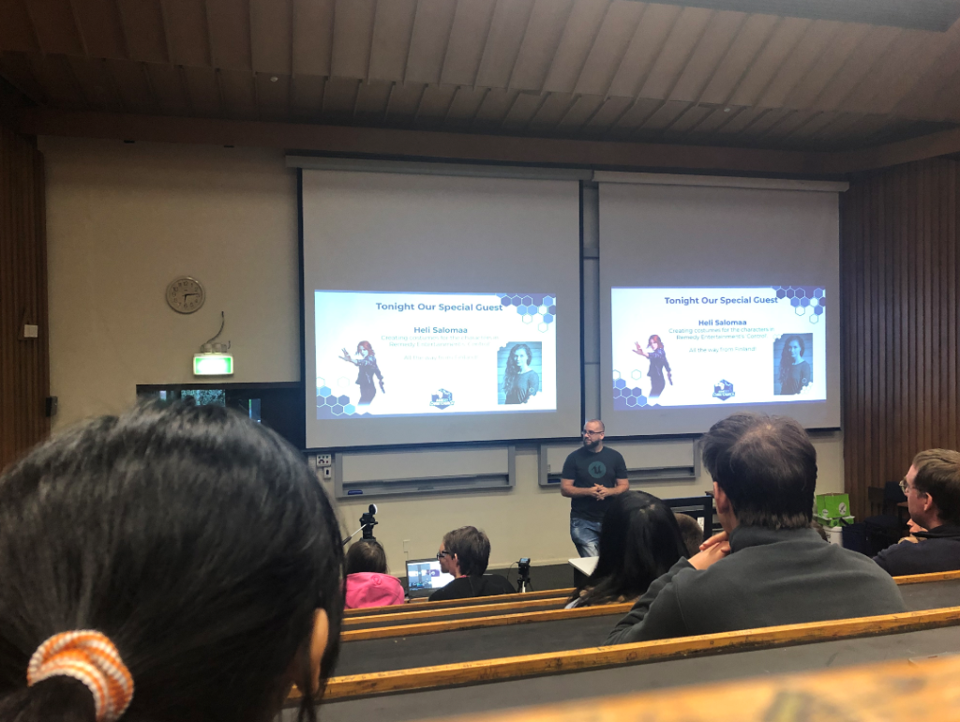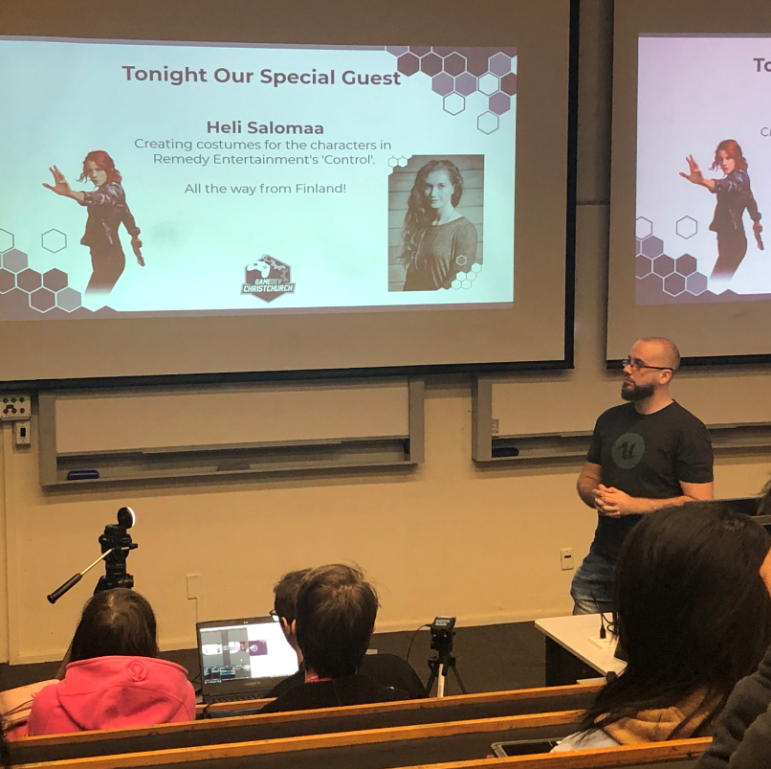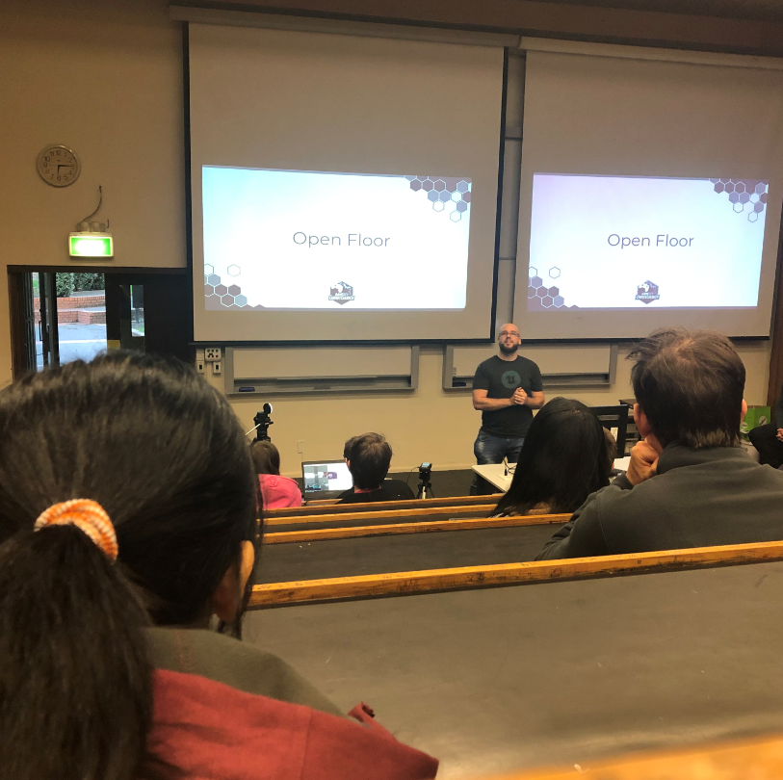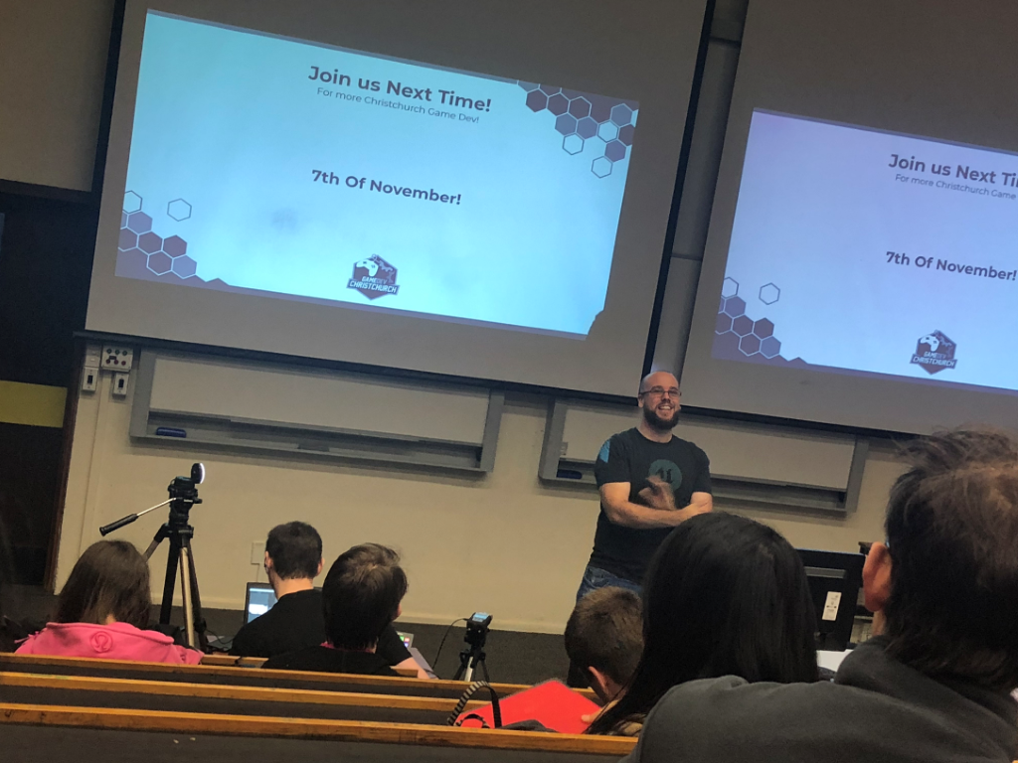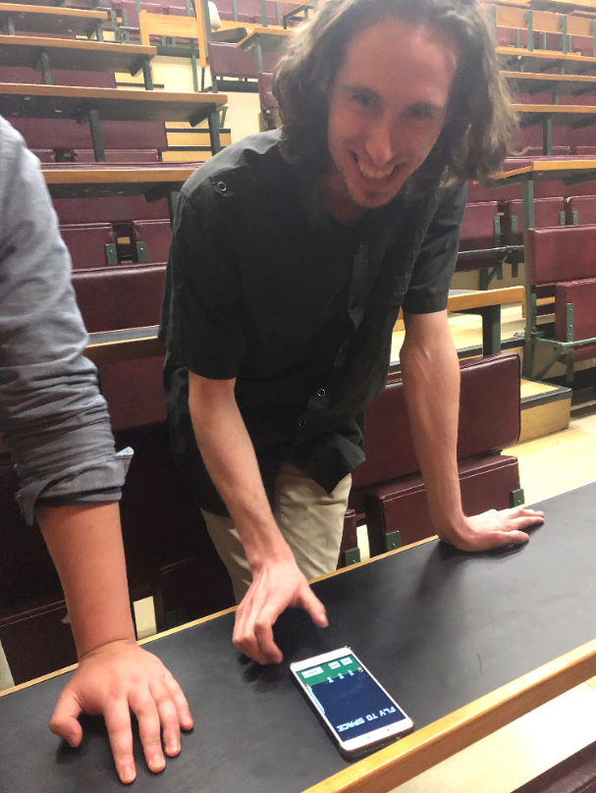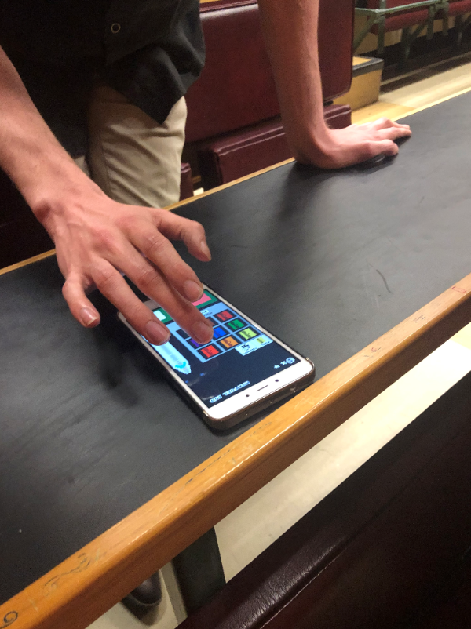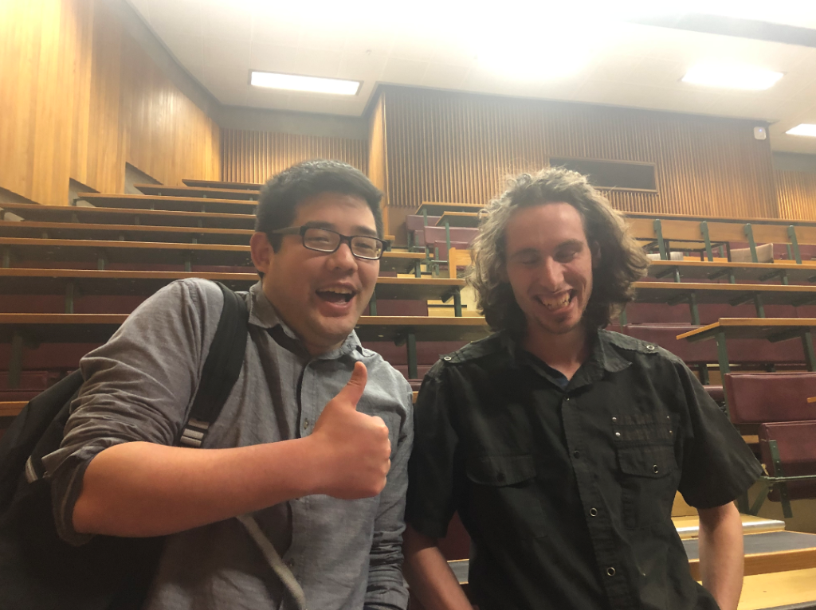

We demonstrated the prototype to Len Starker (Mobile Number: 0221943256). He is a Mobile Developer working at Verizon Connect in Christchurch.

The minigame that was demonstrated to Len was the version 0.3 prototype (i.e. what we have implemented at the end of Sprint 3).

## Feedback

Len enjoyed playing the minigame and liked the concept. In particular, he liked the unique start screen and the build phase of the game.

He provided the following suggestions for improvements that could be made to the minigame.

**Start Screen**

* This screen is not intuitive for where to move the character to start the game. A suggestion is to include tutorial tips in the form of pop-ups.
* For the milestones display, there needs to be a tip on how to close it.

**Build Phase**

* The home button is awkwardly placed on the bottom-right of the screen. This is very prone to be accidently pressed. Should be placed at the top-left corner.
* The purchase button is too small.
* There also needs to be tutorial pop-up messages explaining what to do.
* The portrait for the tourist looks weird and compressed.
* If I cannot purchase an item, there needs to be a warning alert to provide a response for the player.

**Launch Phase**

* There needs to be a clear blue-to-black transition for when the ship leaves the earth’s atmosphere. This is because the gravity mechanic is not applied outside of the atmosphere and the player needs to know of that change.
* The bottom player navigational buttons need to be improved. The current ‘confirm’ place holder button needs to either be changed or removed.
* The actual eco-products are a bit too small and hard to see.
* The ‘WARNING NO FUEL’ and the milestone messages both share the same screen space when both are enabled. Place the warning somewhere else.
* The ‘End launch’ button is awkwardly placed on the top-right corner. Either automatically end the launch when the rocket is destroyed or place the button somewhere better.

**Score screen**

* The score screen is too transparent. The background build phase screen is too visible makes the score screen hard to read.
* The buttons that are not behind the score screen panel is still accessible.

**Non-implemented features**

*This section contains feedback for features that had not been implemented for the minigame but were addressed by Len.*

* For the Start Screen, the stands for all the different menu options are the same.
* For the Start Screen, the player character should have an animated walk.
* For the Build Phase, the adding of tourists and cargo space needs to be more intuitive. Better pictures and tips will help.
* For the levels, the time each level should take should ramp up depending on difficulty.